MySQL Date Time [21 Exercises]

1. Write a query to display the first day of the month (in datetime format) three months before the current month.

[SELECT](http://localhost/phpmyadmin/url.php?url=https://dev.mysql.com/doc/refman/8.0/en/select.html) date(((PERIOD_ADD(EXTRACT(YEAR_MONTH FROM CURDATE()),-3)*100)+1));

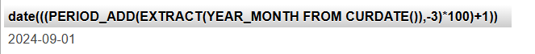

1. Write a query to display the last day of the month (in datetime format) three months before the current month.

[SELECT](http://localhost/phpmyadmin/url.php?url=https://dev.mysql.com/doc/refman/8.0/en/select.html) (SUBDATE(ADDDATE([CURRENT_DATE](http://localhost/phpmyadmin/url.php?url=https://dev.mysql.com/doc/refman/8.0/en/date-and-time-functions.html%23function_current_date)(),[INTERVAL](http://localhost/phpmyadmin/url.php?url=https://dev.mysql.com/doc/refman/8.0/en/comparison-operators.html%23function_interval) 1 MONTH),[INTERVAL](http://localhost/phpmyadmin/url.php?url=https://dev.mysql.com/doc/refman/8.0/en/comparison-operators.html%23function_interval) DAYOFMONTH([CURRENT_DATE](http://localhost/phpmyadmin/url.php?url=https://dev.mysql.com/doc/refman/8.0/en/date-and-time-functions.html%23function_current_date)()) DAY)) AS LastDayOfTheMonth;

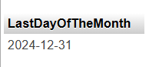

1. Write a query to get the distinct Mondays from hire_date in employees tables.

[SELECT](http://localhost/phpmyadmin/url.php?url=https://dev.mysql.com/doc/refman/8.0/en/select.html) DISTINCT(STR_TO_DATE(CONCAT (YEARWEEK(HIRE_DATE)),'%x%v%w' )) FROM employees;

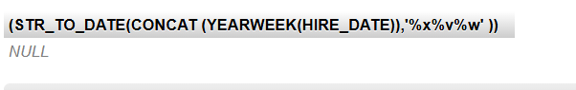

1. Write a query to get the first day of the current year.

[SELECT](http://localhost/phpmyadmin/url.php?url=https://dev.mysql.com/doc/refman/8.0/en/select.html) MAKEDATE(EXTRACT(YEAR FROM [CURRENT_DATE](http://localhost/phpmyadmin/url.php?url=https://dev.mysql.com/doc/refman/8.0/en/date-and-time-functions.html%23function_current_date)),1);

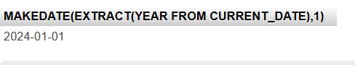

1. Write a query to get the last day of the current year.

[SELECT](http://localhost/phpmyadmin/url.php?url=https://dev.mysql.com/doc/refman/8.0/en/select.html) STR_TO_DATE(CONCAT(12,31,EXTRACT(YEAR FROM CURDATE())),'%m%d%Y');

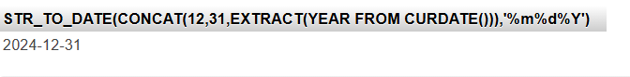

1. Write a query to calculate the age in year.

[SELECT](http://localhost/phpmyadmin/url.php?url=https://dev.mysql.com/doc/refman/8.0/en/select.html) YEAR([CURRENT_TIMESTAMP](http://localhost/phpmyadmin/url.php?url=https://dev.mysql.com/doc/refman/8.0/en/date-and-time-functions.html%23function_current_timestamp))- YEAR("1992-03-29")- ([RIGHT](http://localhost/phpmyadmin/url.php?url=https://dev.mysql.com/doc/refman/8.0/en/string-functions.html%23function_right)([CURRENT_TIMESTAMP](http://localhost/phpmyadmin/url.php?url=https://dev.mysql.com/doc/refman/8.0/en/date-and-time-functions.html%23function_current_timestamp), 5)<[RIGHT](http://localhost/phpmyadmin/url.php?url=https://dev.mysql.com/doc/refman/8.0/en/string-functions.html%23function_right)("1992-03-29", 5)) as age;

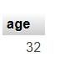

1. Write a query to get the current date in the following format.  
   Sample date : 2014-09-04  
   Output : September 4, 2014

[SELECT](http://localhost/phpmyadmin/url.php?url=https://dev.mysql.com/doc/refman/8.0/en/select.html) DATE_FORMAT([CURRENT_DATE](http://localhost/phpmyadmin/url.php?url=https://dev.mysql.com/doc/refman/8.0/en/date-and-time-functions.html%23function_current_date)(),'%M %e, %Y') AS Current_YEAR;

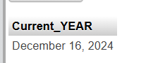

1. Write a query to get the current date in Thursday September 2014 format.  
   Thursday September 2014

[SELECT](http://localhost/phpmyadmin/url.php?url=https://dev.mysql.com/doc/refman/8.0/en/select.html) DATE_FORMAT([CURRENT_DATE](http://localhost/phpmyadmin/url.php?url=https://dev.mysql.com/doc/refman/8.0/en/date-and-time-functions.html%23function_current_date)(),'%W %M %Y') AS Current_YEAR;

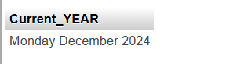

1. Write a query to extract the year from the current date.

[SELECT](http://localhost/phpmyadmin/url.php?url=https://dev.mysql.com/doc/refman/8.0/en/select.html) EXTRACT(YEAR FROM NOW()) AS Current_YEAR;

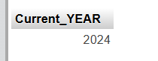

1. Write a query to get the DATE value from a given day (number in N).  
   Sample days: 730677  
   Output : 2000-07-11

[SELECT](http://localhost/phpmyadmin/url.php?url=https://dev.mysql.com/doc/refman/8.0/en/select.html) FROM_DAYS(730677);

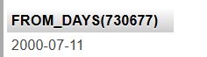

1. Write a query to get the first name and hire date from employees table where hire date between '1987-06-01' and '1987-07-30'

[SELECT](http://localhost/phpmyadmin/url.php?url=https://dev.mysql.com/doc/refman/8.0/en/select.html) FIRST_NAME,HIRE_DATE FROM employees WHERE HIRE_DATE BETWEEN '1987-06-01 00:00:00'[AND](http://localhost/phpmyadmin/url.php?url=https://dev.mysql.com/doc/refman/8.0/en/logical-operators.html%23operator_and) '1987-07-30 23:59:59';

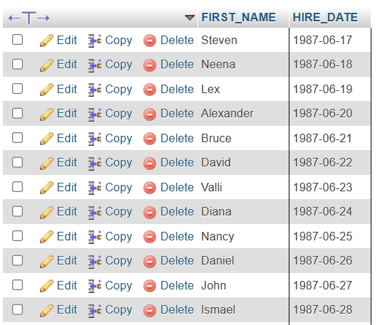

1. Write a query to display the current date in the following format.  
   Sample output: Thursday 4th September 2014 00:00:00

[SELECT](http://localhost/phpmyadmin/url.php?url=https://dev.mysql.com/doc/refman/8.0/en/select.html) date_format(CURDATE(),'%W %D %M %Y %T') AS 'CURRENT DATE';

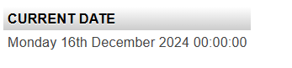

1. Write a query to display the current date in the following format.  
   Sample output: 05/09/2014

[SELECT](http://localhost/phpmyadmin/url.php?url=https://dev.mysql.com/doc/refman/8.0/en/select.html) date_format(CURDATE(),'%d/%m/%Y');

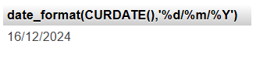

1. Write a query to display the current date in the following format.  
   Sample output: 12:00 AM Sep 5, 2014

[SELECT](http://localhost/phpmyadmin/url.php?url=https://dev.mysql.com/doc/refman/8.0/en/select.html) date_format(CURDATE(),'%l:%i %p %b %e, %Y');

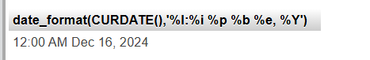

1. Write a query to get the firstname, lastname who joined in the month of June.

[SELECT](http://localhost/phpmyadmin/url.php?url=https://dev.mysql.com/doc/refman/8.0/en/select.html) FIRST_NAME,LAST_NAME FROM employees WHERE MONTH(HIRE_DATE)=06;

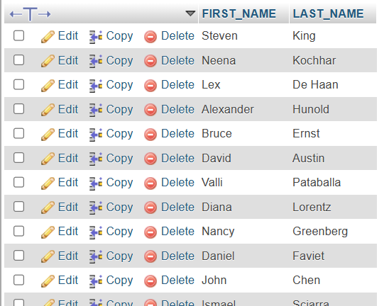

1. Write a query to get the years in which more than 10 employees joined.

[SELECT](http://localhost/phpmyadmin/url.php?url=https://dev.mysql.com/doc/refman/8.0/en/select.html) DATE_FORMAT(HIRE_DATE,'%Y') FROM employees GROUP BY DATE_FORMAT(HIRE_DATE,'%Y') HAVING [COUNT](http://localhost/phpmyadmin/url.php?url=https://dev.mysql.com/doc/refman/8.0/en/aggregate-functions.html%23function_count)(EMPLOYEE_ID) > 10;

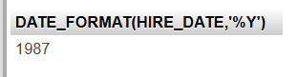

1. Write a query to get first name of employees who joined in 1987. [SELECT](http://localhost/phpmyadmin/url.php?url=https://dev.mysql.com/doc/refman/8.0/en/select.html) FIRST_NAME,LAST_NAME,HIRE_DATE FROM employees WHERE YEAR(HIRE_DATE)=1987;

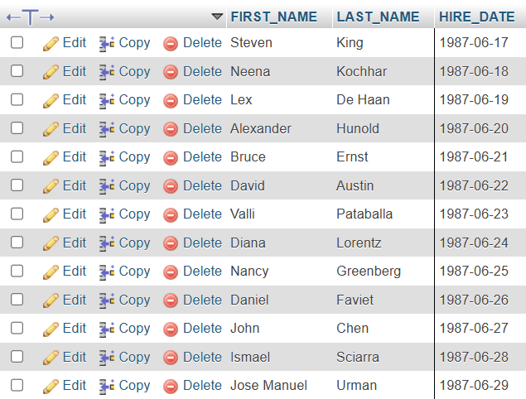

1. Write a query to get department name, manager name, and salary of the manager for all managers whose experience is more than 5 years.

[SELECT](http://localhost/phpmyadmin/url.php?url=https://dev.mysql.com/doc/refman/8.0/en/select.html) DEPARTMENT_NAME,FIRST_NAME,SALARY FROM departments D JOIN employees E ON (D.MANAGER_ID=E.MANAGER_ID) WHERE (SYSDATE()-HIRE_DATE) / 365 > 5;

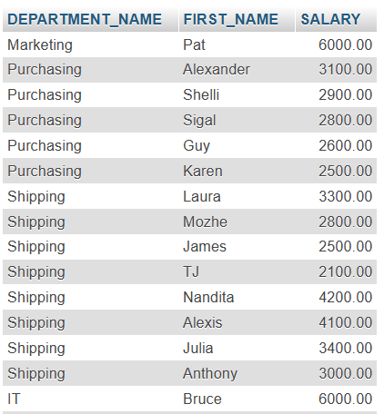

1. Write a query to get employee ID, last name, and date of first salary of the employees. [SELECT](http://localhost/phpmyadmin/url.php?url=https://dev.mysql.com/doc/refman/8.0/en/select.html) employee_id, last_name, hire_date, LAST_DAY(hire_date) FROM employees;

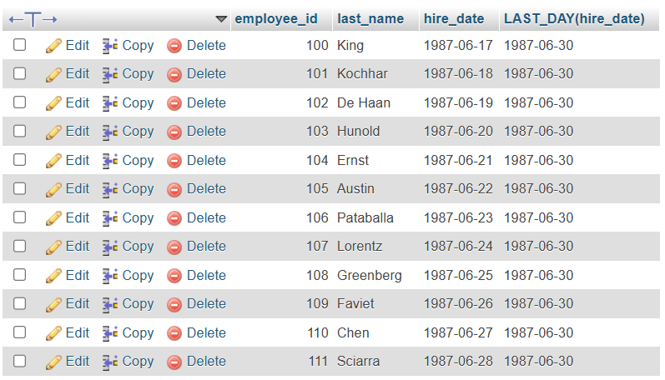

1. Write a query to get first name, hire date and experience of the employees.

[SELECT](http://localhost/phpmyadmin/url.php?url=https://dev.mysql.com/doc/refman/8.0/en/select.html) FIRST_NAME, SYSDATE(), HIRE_DATE, DATEDIFF(SYSDATE(), hire_date)/365 FROM employees;

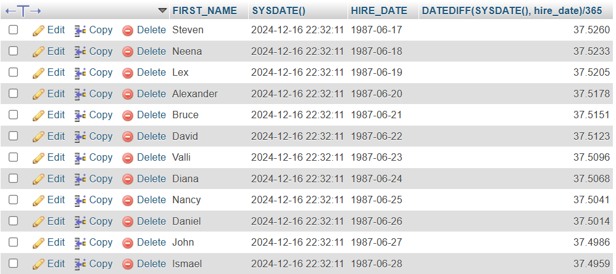

1. Write a query to get the department ID, year, and number of employees joined.

[SELECT](http://localhost/phpmyadmin/url.php?url=https://dev.mysql.com/doc/refman/8.0/en/select.html) DEPARTMENT_ID, DATE_FORMAT(HIRE_DATE,'%Y'), [COUNT](http://localhost/phpmyadmin/url.php?url=https://dev.mysql.com/doc/refman/8.0/en/aggregate-functions.html%23function_count)(EMPLOYEE_ID) FROM employees GROUP BY DEPARTMENT_ID, DATE_FORMAT(HIRE_DATE, '%Y') ORDER BY DEPARTMENT_ID;

